**Adjusting the Waveform and CRT Monitors**

**1. How to read a waveform and vectorscope signal**

**1.1 Waveform:** A waveform is used to evaluate the brightness/luminance of your image, regardless of the color. The units are in IRE, and there are a total of 140 of them.

The illustration below is of a waveform monitor reticule. While it has several mysterious things included in the graphics, the most important are the horizontal lines that go from 100 at the top to -40 at the bottom with a heavy subdivided line about a third of the way up from the bottom at 0 on this scale. These are the primary measuring lines.

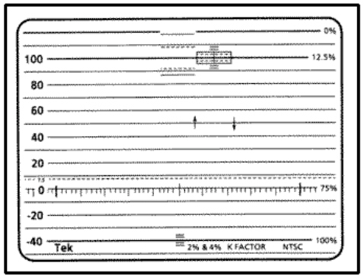

The video portion of the scale is from zero to one hundred, while the area below zero is for synchronizing signals. The area between 7.5 and 0 IRE is referred to as super black. While the technical issue that plagued early television sets has long ago been solved, this artificially high black level is the standard for NTSC video.Note also that there are two lines above 100 at 110 and 120 IRE. This is called the Superwhite area, where really strong light peaks (glints of the sun off shiny objects, for instance) may travel. What we perceive as white on a monitor is not 100 IRE but is actually around 75 to 85 IRE depending upon the visual content of the picture. So you should think of 100 IRE and above not as whites but as highlights that are a normal part of the picture. As an illustration, look at the waveform below on the left:

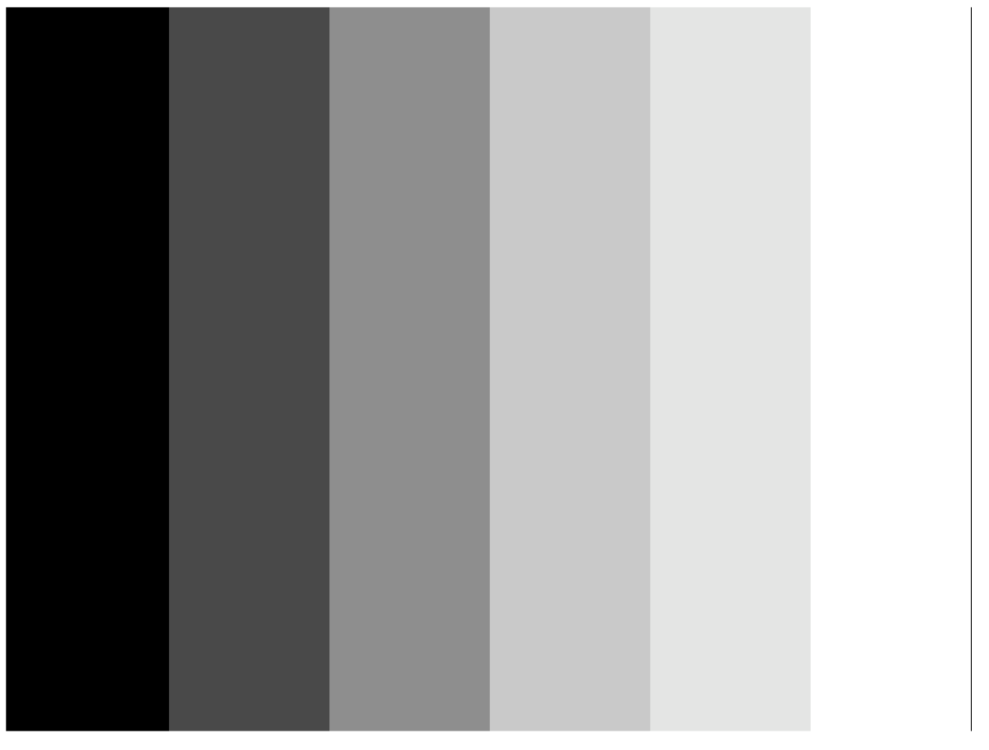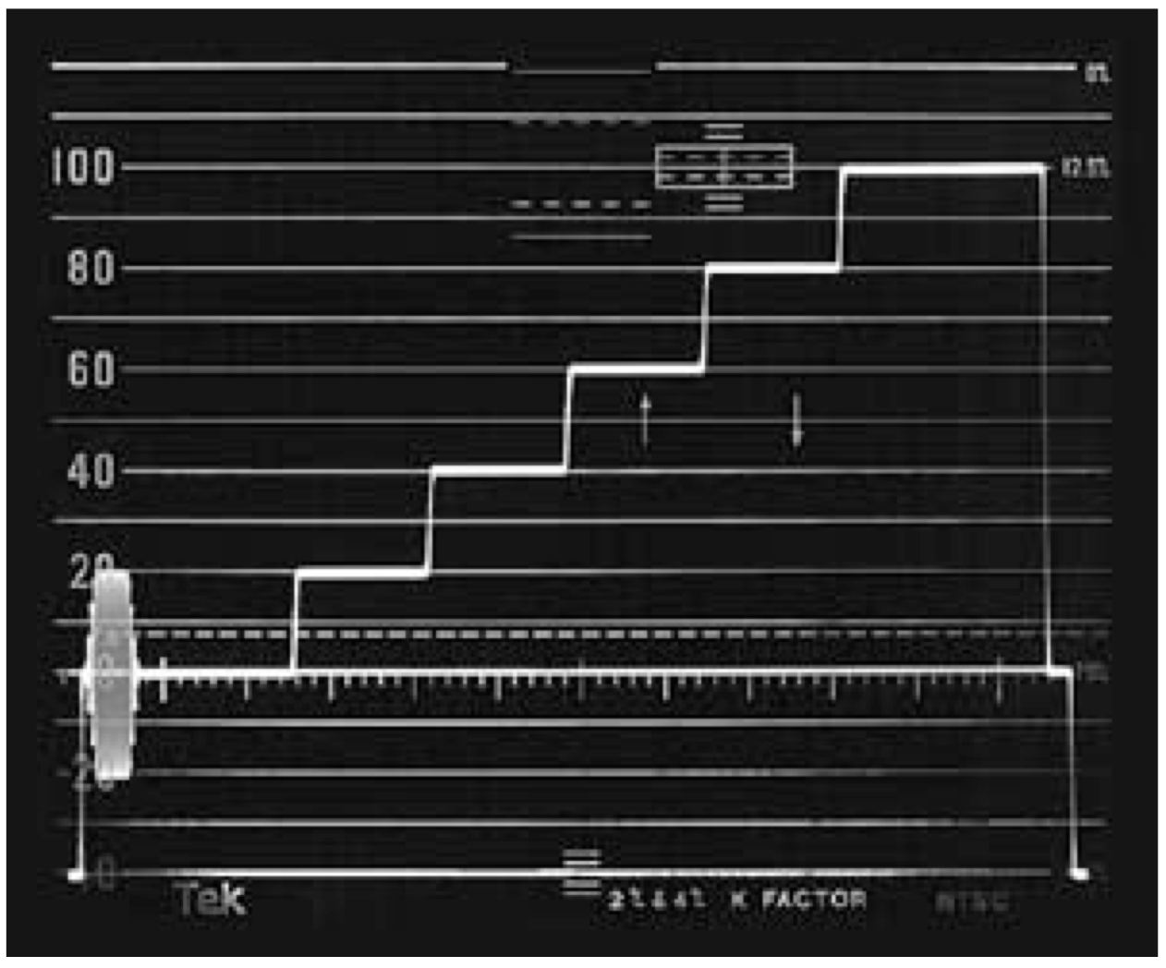

**→**

The image of the gray scale is represented in the waveform on the left. We see a simple “staircase” test signal that has levels at 0, 20, 40, 60, 80, and 100 IRE from the left to the right. The step on the left would be below black, the next step dark gray, the next step a bit lighter gray, and so on until we get to white.

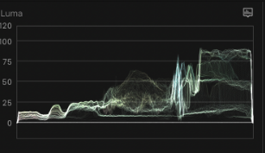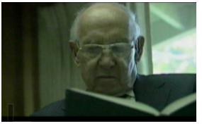

Additionally, the image in a waveform corresponds from left to right, while the top to bottom is the representation of the brightness. Looking at the two images above, we can see the image of the man reading on the waveform on the right. While the dark hallway on the left of the image reads at around 10 IRE on the left of the waveform, the window on the right is reading at around 90 IRE on the right of the waveform.

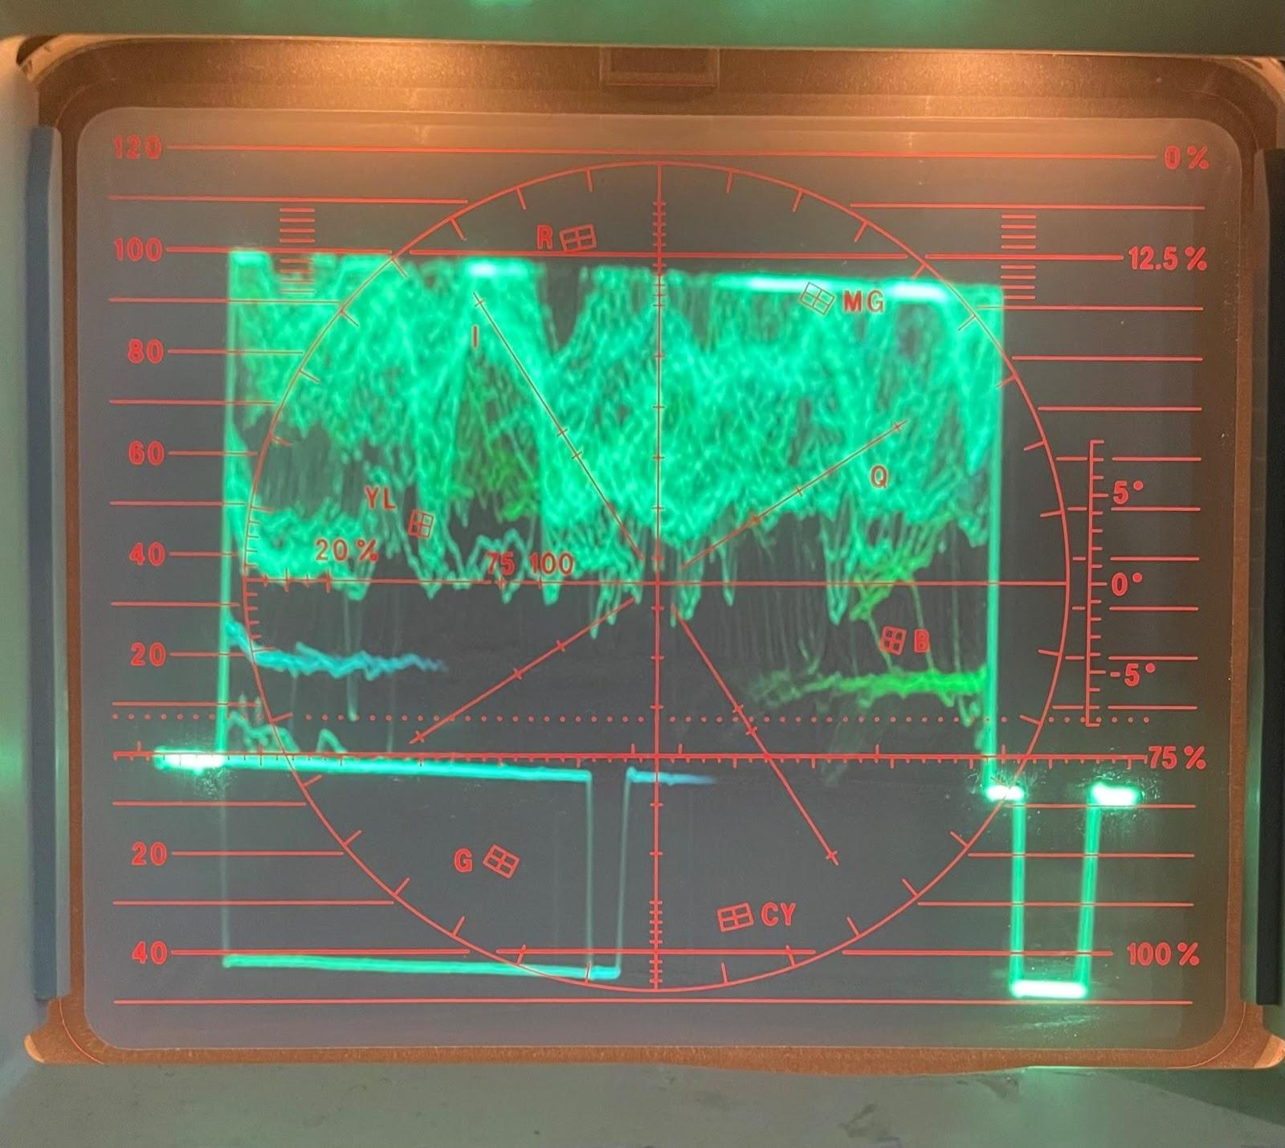

Waveform clipping is when the peaks of your waveform are . make sure the image isn’t clipping because it means information is being cut off. If your waveform is clipping, you will need to adjust the settings on the TBC.

**1.2 Vectorscope:**

A vectorscope is basically a color wheel. It displays the hue and saturation information in the image, it will not provide any information on the brightness of your image. The further the markings are from the center, the more saturation you have in your image. The cross hair in the center of the wheel represents zero saturation.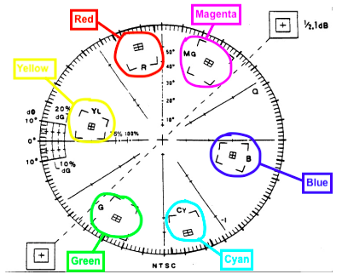

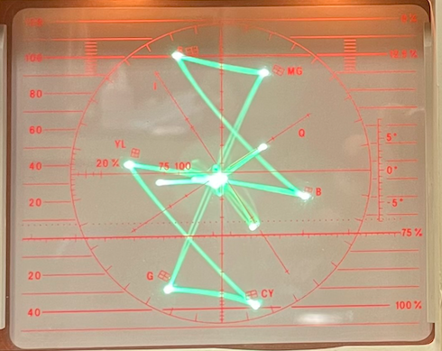

**→**

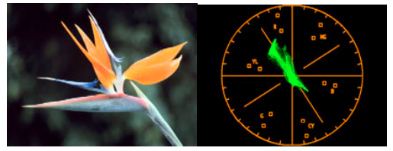

Looking at the flower above, we can see it has a particular shade of orange that can be clearly seen on the vectorscope.

**2. Adjusting the Compuvideo: Waveform Monitor and Vectorscope (WAV)**

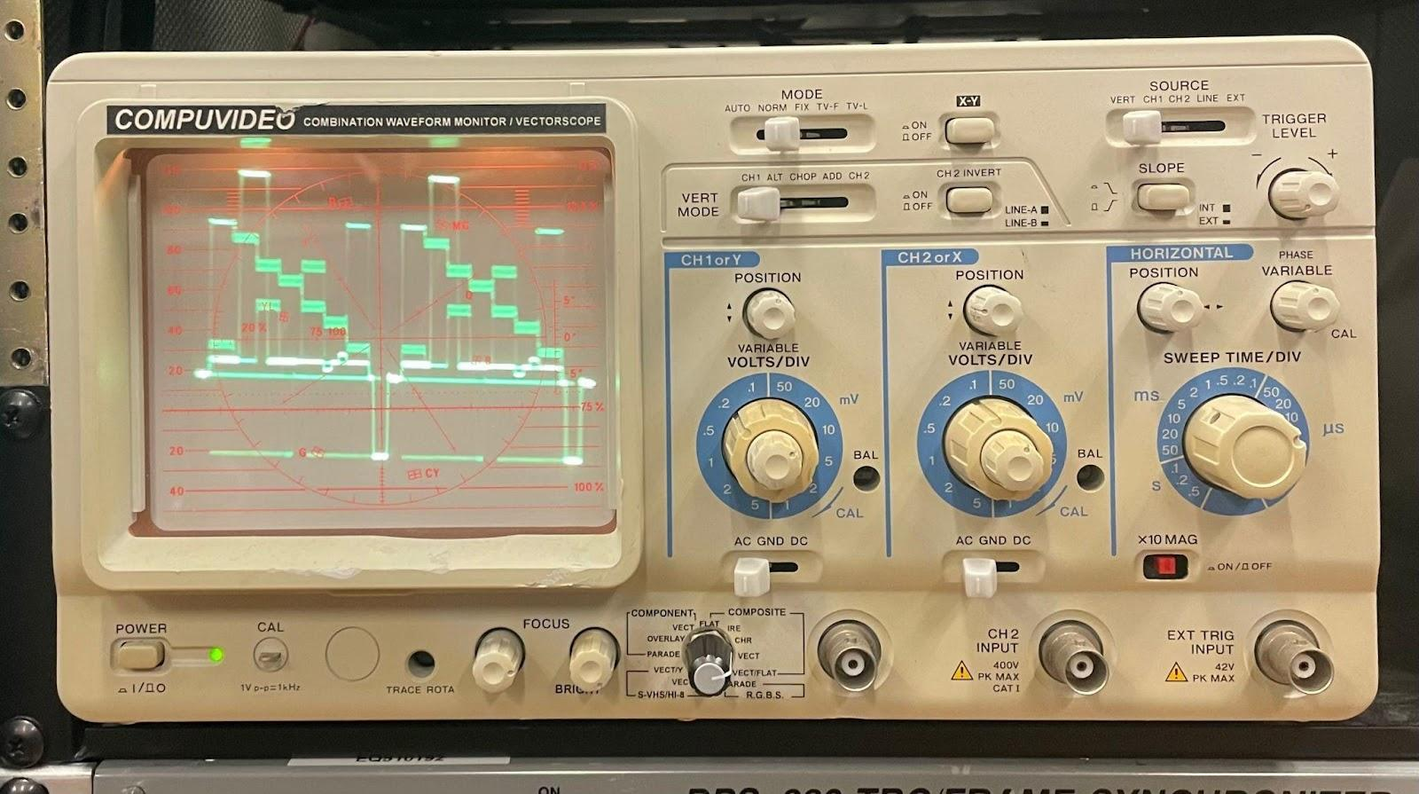

The Compuvideo is a combined waveform monitor and vectorscope that we use to monitor the video signal in the system. It is not an intuitive piece of equipment, so make sure to adjust the settings correctly.

**2.1 Power on the video racks and appropriate decks**

To get started, turn on the video rack beginning with the Cyberpower strip, Test Signal Generator (TSG) and composite switchers (Mon1-SWR and Mon2-SWR), Compuvideo (WAV), and Monitor 1 (Mon1).

* Set Mon1-SWR to ‘TSG’
* Set the TSG to ‘COLOR BARS.’ The TSG will automatically set to Black Burst.

* *The TSG should automatically power on when the Cyberpower is switched on. The power button for the TSG is located on the back if needed.*

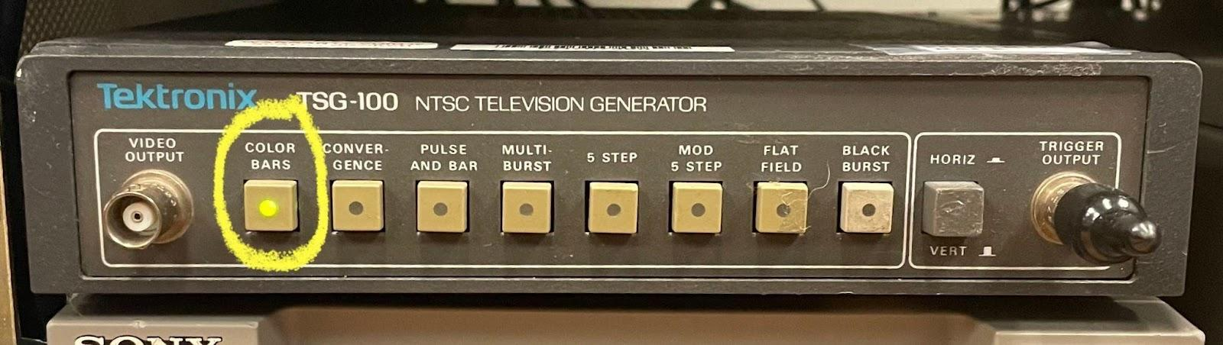

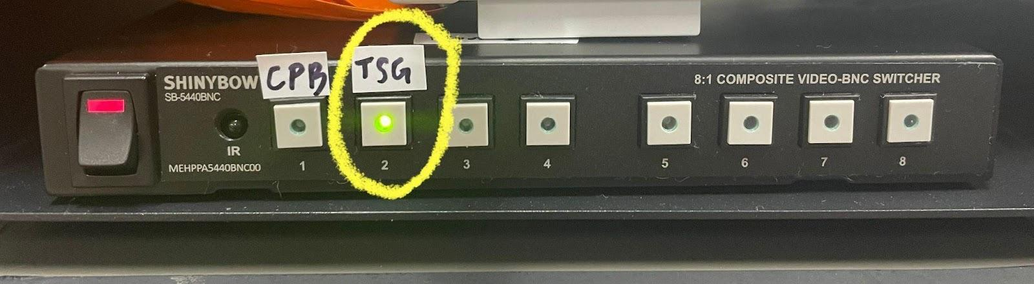



At this point you should be able to see the SMPTE color bars displayed on Monitor 1. If you do not see color bars on Monitor 1, double check the settings are correct on the TSG and Mon1-SWR. If they are, go ahead and toggle between the CH B(Y/C) button on Mon1 until you see the color bars.

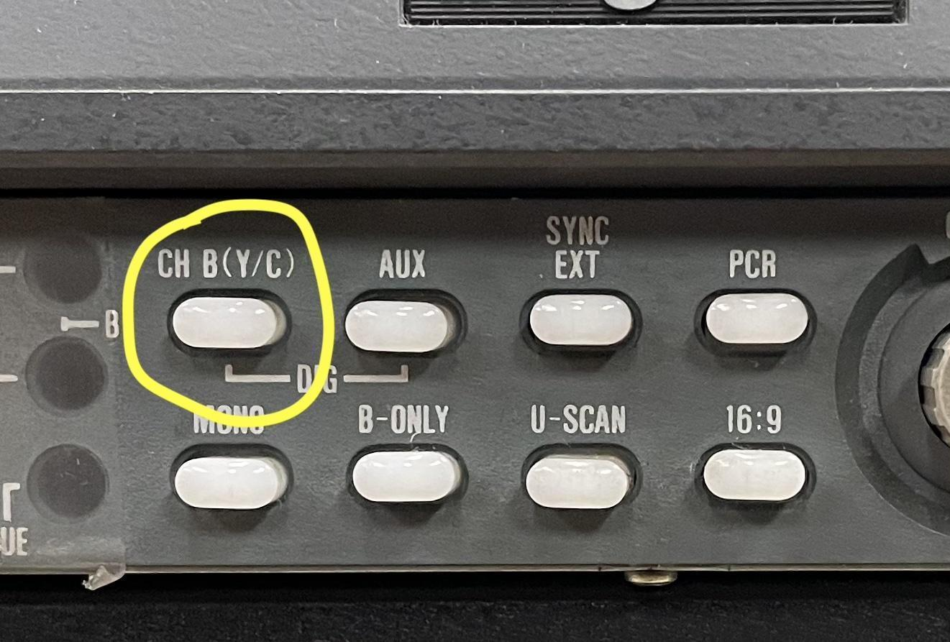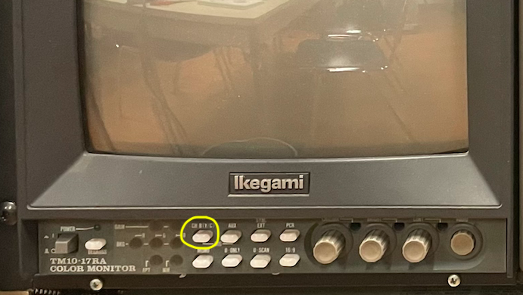

→

**2.2 Set the Compuvideo Settings**

* Set the correct settings outlined below. Only adjust these knobs, you do need to adjust any of the voltage knobs.



| **KNOB** | **SETTING** |
| --- | --- |
| Mode | Normal |
| VERT MODE | CH1 |
| X-Y | Off (button not engaged) |
| CH. 2 INV | On (button engaged) |
| Source | VERT |
| Slope | Off (button not engaged) |
| Sweep Time/ DIV | 10 µs |
| Composite | CHR - waveform display  VECT/FLAT - vectorscope display |

**2.3 Adjusting the position of the waveform and vectorscope on the WAV**

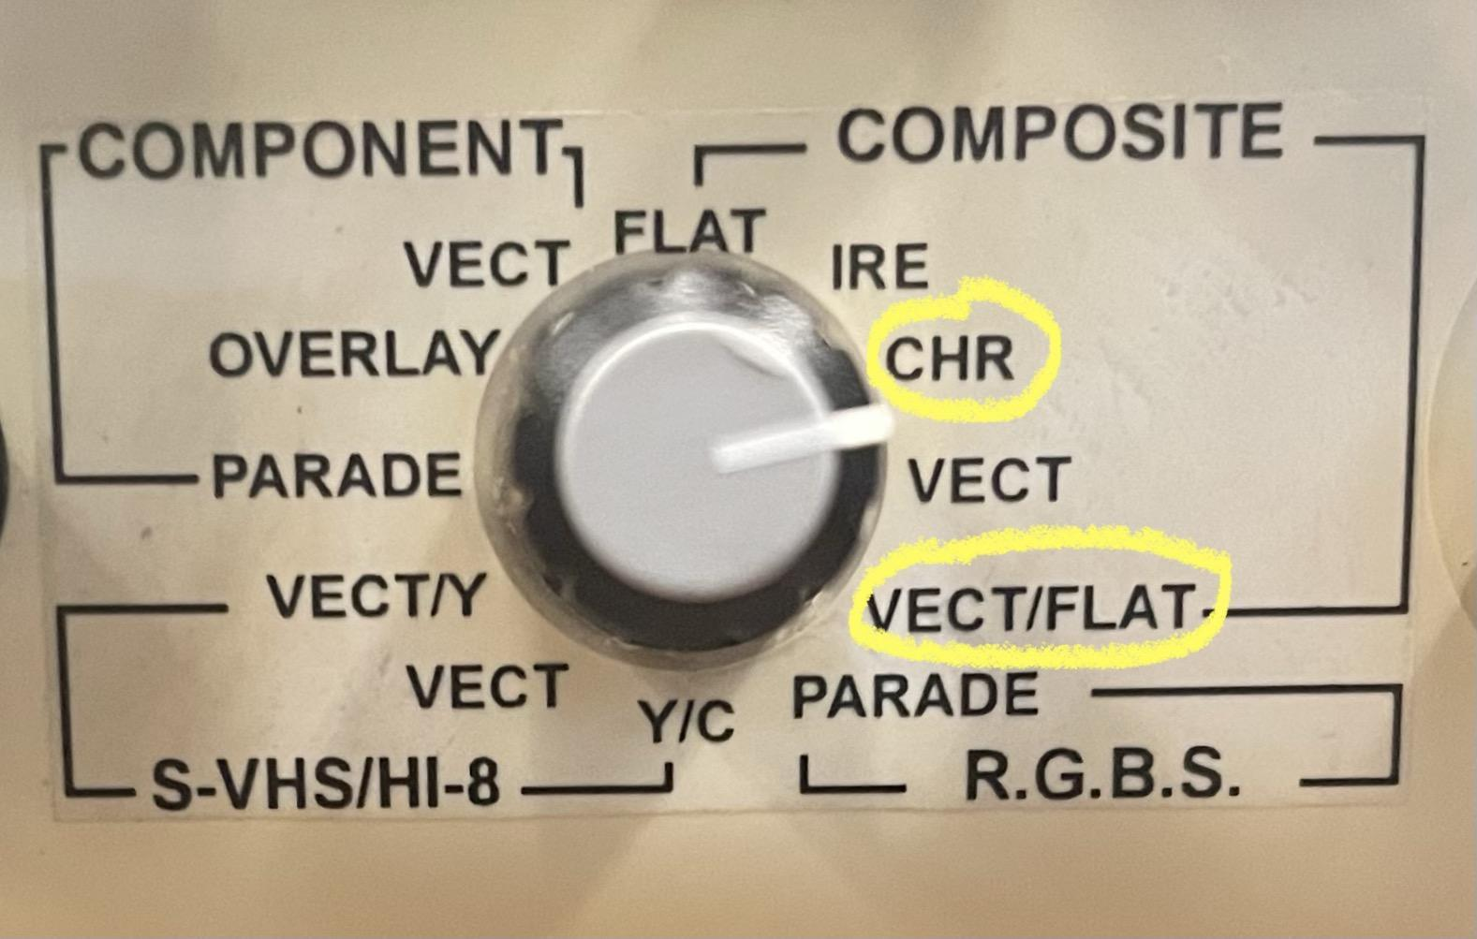

The last setting in the previous table labeled ‘Composite’ is the switch that allows you to switch between the waveform and vectorscope displays. Since the TSG is only sending out a composite video signal, make sure you are in the composite section when adjusting these settings. If all the settings are correct, you should now be able to switch between the ‘CHR’ and ‘VECT/FLAT’ and see the displays below:

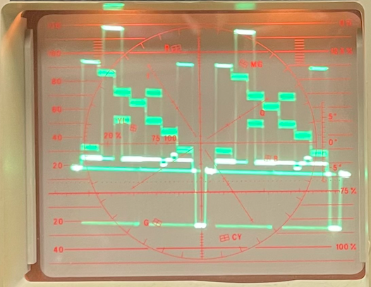

Now that we can see the TSG color bars on the WAV, take a moment to study them.

Waveform:

* For the waveform monitor, adjustments should be made on the stairs that represent the SMPTE color bars. White is at the top, black is at the bottom, and all the mid tones are in between.
* The top stair (that represents the white level) should be at 100 IRE.
* The bottom of the stairs (that represents the five black levels) should be at the 7.5 IRE dashed line. The bottom line (front porch) should be at 0 IRE.
* A correctly adjusted video signal should look like this:

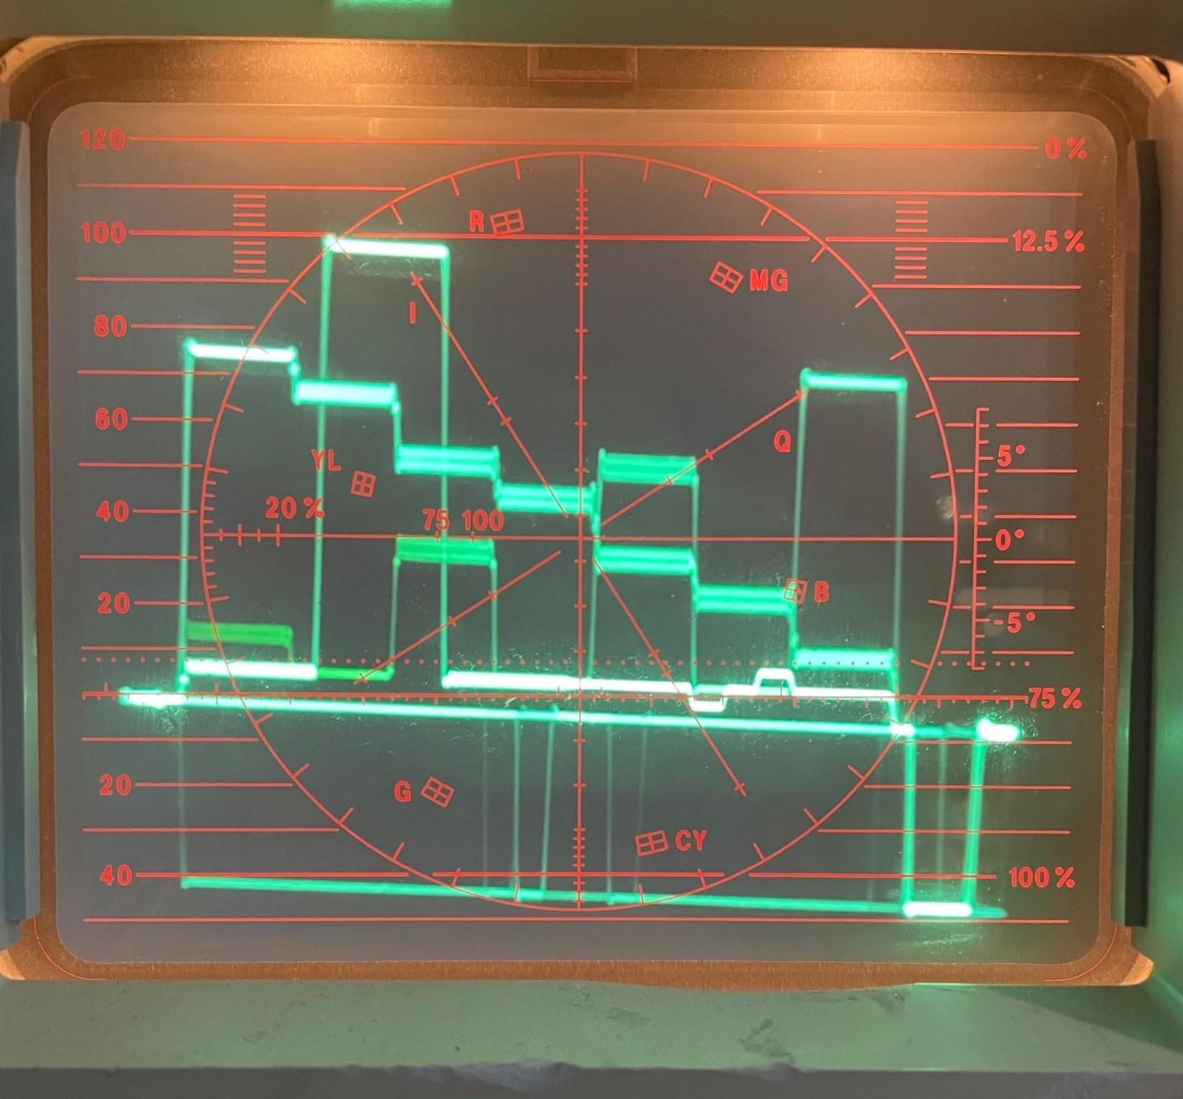

**Vectorscope:**

* For the vectorscope, there are 6 targets that are the aim points for the primary and secondary colors.
* Use the vertical, horizontal, and phase knobs to position the very center of the waveform exactly in the center of the reticule.   
    
    
  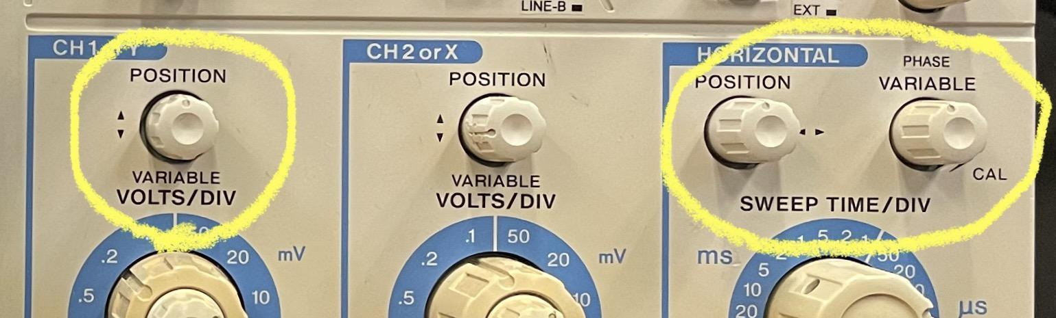
* Each color should be aimed at the correct target and the burst lined up. A correctly adjusted signal should look like this:



**3. Adjusting the CRT Monitors**

Now that the WAV has been calibrated, we can go ahead and calibrate the CRT monitors. Don’t calibrate the monitors for every transfer. Conduct routine calibration on all decks every few months or if an instance of distortion occurs.

We have two monitors in our system, the Pre-Digitization Monitor 1 (Mon1) and the Post-Digitization Monitor 2 (Mon2). To calibrate the monitors, you will need to rely on your eyes so that the SMPTE color bars are displaying correctly.

For the Pre-Dig Mon1, use the gray knobs on the bottom right labeled ‘Chroma’, ‘Bright’, and ‘Cont’ to make your adjustments. 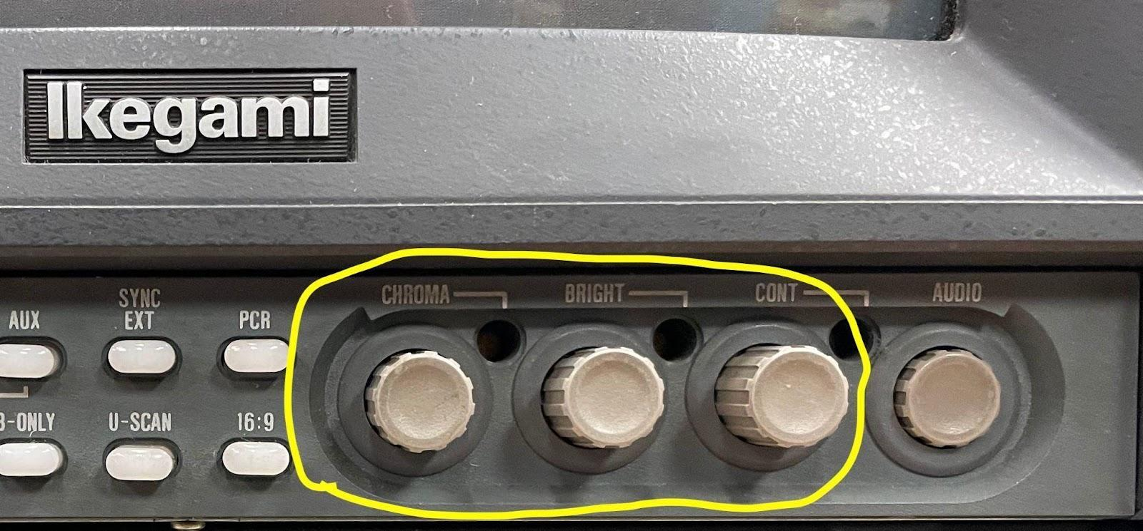

* **Step 1:** Turn on the monitor and allow it to warm up for a few minutes if it has not been on already.
* **Step 2:** Make sure the color bars are displayed on your monitor. If they are not, please refer to section 2.1 of this document.
* **Step 3:** Set the contrast to the midpoint and turn the chroma all the way down until the bars are white and black.
* **Step 4:** Notice the PLUGE bars, the three narrow bars labeled 3.5, 7.5, and 11.5 on 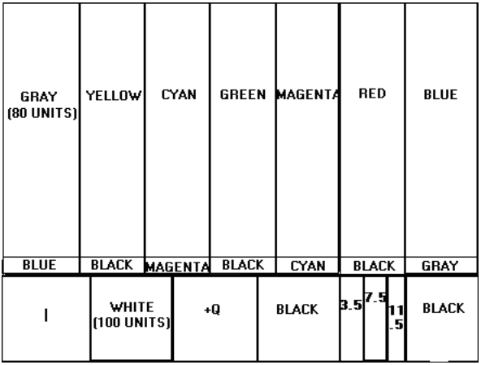



the bottom right of the screen. Adjust the CRT brightness until the middle PLUGE bar (7.5) is not quite visible. The lightest bar on the right (11.5) should be barely visible. If it’s not visible, turn the brightness up until it is.

*\*Since 7.5 is as dark as video gets, you should not see any difference between the left bar (3.5) and the middle bar (7.5). There*

*should be no dividing line between these two bars. The only division you should see is between 11.5 and 7.5.*

* **Step 5:** Turn the contrast on the CRT all the way up to set the control for a proper white level. The white (100 units) bar will flare and bloom. Turn the contrast down until the white bar just begins to respond. The bars should look like this: 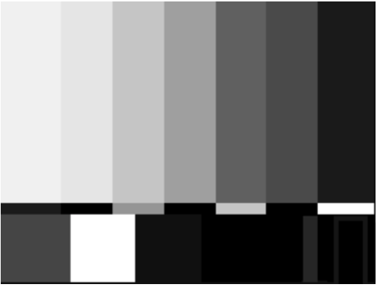

* **Step 6:** Adjust the colors by setting the chroma and phase (hue) to the middle position on the CRT. Use both the adjust the yellow and magenta. The yellow should be a lemon yellow without purple or green. The magenta should not be purple or red. The bars should look like this: (If flesh tones don’t look right, you may need to continue making adjustments to the chroma and phase.) 
* Useful calibration info: Tektronix 1740 A manual page 55.
* For more advanced workflow, borrow from this document:<http://blog.ieba.com/wp-content/uploads/2010/06/ReadWaveformVector.pdf>